<<COURT_NAME>>

|  |  |
| --- | --- |
| <<PROVIDER_SUITNAME>>,  a/a/o <<INJUREDPARTY_NAME>>    Plaintiff,  vs.  <<INSURANCECOMPANY_SUITNAME>>  Defendant.  _____________________________________/ | Case No. <<INDEXORAAA_NUMBER>> |

**MOTION FOR ENLARGEMENT OF TIME**

Plaintiff, <<INJUREDPARTY_NAME>>, by and through the undersigned counsel, hereby [!plaintiff#!files/file] this Motion for Enlargement of Time, and in support thereof further [!plaintiff#!states/state]:

1. Plaintiff, <<INJUREDPARTY_NAME>>, is obligated to file discovery responses in this case.

2. That as of the date of this motion, Plaintiff is unable to file the foregoing because circumstances beyond its control.

3. That this motion is made in good faith and prior to the time by which Plaintiff is obligated to file said discovery responses.

WHEREFORE, Plaintiff, <<INJUREDPARTY_NAME>>, requests the Court to enter an Order granting this Motion for Enlargement of Time, and grant such other further relief that is just and appropriate under the circumstances.

**CERTIFICATE OF SERVICE**

I HEREBY CERTIFY that on February 19, 2022, a true and correct copy of the foregoing was filed and served through the Florida E-File Portal to <<OPPOSING_COUNSEL_NAME>>.

**Florida Insurance Law Group, LLC**

8724 Sunset Drive, #260, Miami, FL 33173

Tel. (305) 906-4262

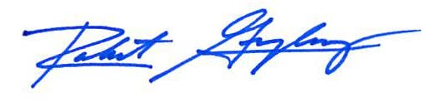

Robert F. Gonzalez, Esq.

Fla. Bar No. 68865